

**KAMPALA CAPITAL CITY AUTHORITY**

**ENVIRONMENTAL SANITATION SERVICE LICENSE (ESS) APPLICATION PROCESS**

**JULY, 2023**

# DOCUMENT RELEASE NOTE.

**Notice No.:** KCCA/URS/Environment Sanitation Service License (ESS) /1.0

**Name of Client:** Kampala Capital City Authority.

**Project Name:** Environmental Sanitation Service License (ESS) Application.

## Document Details.

|  |  |  |
| --- | --- | --- |
| Name | Version no. | Description |
| Environmental Sanitation Service License- 1.0 | Version 1.0 |  |

## Revision details.

|  |  |  |  |
| --- | --- | --- | --- |
| Action taken (add/del/change) | Previous page no. | New page no. | Revision description |
|  |  |  |  |

Change Register serial numbers covered:

The documents or revised pages are subject to document control. Please keep them up-to-date using the release notices from the distributor of the document.

This is a confidential document.

**Process Owner:** Directorate of Public Health Services and Environment.

**Approved by (Department of I.C.T);**

**Name: …………………………………**

**Position: …………………………………**

**Signature: ………………………………**

**Date: ……………………………………**

**Approved by (Process Owner);**

**Name: …………………………………**

**Position: …………………………………**

**Signature: ………………………………**

**Date: ……………………………………**

# 

# ABOUT THIS MANUAL

## Purpose

The purpose of this document is to lay down the broad user requirements for the Environmental Sanitation Service License (ESS). This has also been developed after analysing the current challenges and the proposed processes aligned to the KCCA Public Health Services and Environment. This document is for users and the project development team.

## Intended Audience

This document will help:

* Kampala Capital City Authority to understand and approve the requirements of

the proposed module on aquiring Environmental Sanitation Service License (ESS) .

* The acceptance testing team to develop test data and to test the system.
* The maintenance team to understand all aspects of the module, and maintain

it.

## References

* Existing Forms and Formats designed by KCCA and existing forms available with the KCCA.
* BPR proposals suggested and approved by KCCA

## How to Use this Document

All users of this document should carefully read it, and ensure the following:

* All requirements have been listed and detailed.
* Functionality described in this document is clear and unambiguous.

# CONTENTS

DOCUMENT RELEASE NOTE. i

1.1 Document Details. i

1.2 Revision details. i

ABOUT THIS MANUAL ii

1.3 Purpose ii

1.4 Intended Audience ii

1.5 References ii

1.6 How to Use this Document ii

CONTENTS iii

LIST OF ABBREVIATIONS v

DEFINITIONS. vi

1. INTRODUCTION 1

1.1 Purpose 1

1.2 Scope 1

1.3 User Categories 1

1.4 Functionality and User Mapping 2

2. REQUIREMENTS 3

2.1 USER MANAGEMENT 3

2.2 SYSTEM CONFIGURATION 3

2.3 ENVIRONMENTAL SANITATION SERVICE LICENSE MODULE PROCESSES. 4

2.3.1 Application for ESS License Process. 4

2.3.2 Renewal of ESS License Process. 10

2.3.3 Suspension and Revocation of ESS License Process. 15

2.3.4 Review of Appeal Process. 21

2.3.5 Application for ESS License Form 22

2.3.6 Renewal of ESS License Form 24

2.3.7 Suspension or Revocation of ESS License Form 25

3. APPENDICES. 26

# LIST OF ABBREVIATIONS

Below are the acronyms together with their descriptions as used in the document.

|  |  |
| --- | --- |
| Abbreviation / Acronym | Description |
| KCCA | Kampala Capital City Authority |
| URS | User Requirements Specifications |
| ESS License | Environmental Sanitation Service License |
| IOV | Inspector of Vehicles |
| COIN | City Operator Identification Number |

# DEFINITIONS.

Below are the definitions of the different terms that are used in this document.

|  |  |
| --- | --- |
| Term | Description |
| Director | Director Public Health and Environment. |
| Manager / Supervisor | Manager Solid Waste & Environment Management / Manager Inspectorate, Education & Sanitation / Supervisor Solid Waste & Environment Management / Supervisor Sanitation. |
| Officer | Officer Environment Management / Sanitation Officer. |
| City Operator | This is the person who is playing the following roles;   * Applying for an ESS license. * Applying for the renewal of an ESS license. * Re-applying for an ESS license after his / her initial application has been rejected. * The person whose ESS license is being suspended. * The person whose appeal for an ESS license is being reviewed. |
| Approval with comments | This situation takes place when an Officer who has finished carrying out the inspection stage (of determining whether a given City Operator is fit to be given an ESS license) discovers that however much the City Operator has fulfilled most of the requirements needed to get a license, he / she needs to fulfill a few others before being given a license. In this situation, the City Operator is given a time period within which he / she needs to fulfill the remaining requirements. If this time period expires before the City Operator makes the necessary adjustments, his / her application for a license gets rejected. |

# INTRODUCTION

## Purpose

User Requirement Specification (URS) Environmental Sanitation Service License Module has been prepared with a view to provide the following:

1. Details of the user requirements that need to be supported by the application software.
2. A basis for mutual understanding between the users and software design / customization / development team.
3. A basis for subsequent module development and testing.

## Scope

This document gives the framework of the following:

1. Broad functionalities within Environmental Sanitation Service License module.

## User Categories

User Categories for the Environmental Sanitation Service License module will include;

1. Director.
2. Manager / Supervisor.
3. Officer.
4. City Operator.

## Functionality and User Mapping

| **No.** | **System Role Name** | **Functionality(ies)** | **City Operator** | **Director** | **Manager / Supervisor** | **Officer** |
| --- | --- | --- | --- | --- | --- | --- |
|  | Data Entry | * Input application for ESS license. * Input application for renewal of ESS license. | ✓ |  |  | ✓ |
|  | Verification Authority | * Review and update any changes if any in the system. |  |  | ✓ | ✓ |
|  | Approving Authority | * Approve the final outcome of the application for an ESS license. * Approve the final outcome of the application for renewal of an ESS license. * Approve the final outcome of the decision to caution, suspend or revoke an ESS license. |  | ✓ | ✓ |  |

# 

# REQUIREMENTS

The Environmental Sanitation Service License Module includes capturing, the details of the City Operator together with the details of the service which he / she wants to provide. This is intended to provide for real-time acquisition of license details.

Functionalities of the Environmental Sanitation Service License include:

1. Data capture.
2. Generation of a License number.
3. Generating Payment Reference Number (PRN).
4. Schedule of Inspection.
5. Notifications on the system, SMS and emails.
6. MIS Reports.

## USER MANAGEMENT

This module shall be developed to enable users to access the Environmental Sanitation Service License.

## SYSTEM CONFIGURATION

This module shall be developed to enable users register to acquire an Environmental Sanitation Service License.

## ENVIRONMENTAL SANITATION SERVICE LICENSE MODULE PROCESSES.

### Application for ESS License Process.

|  |  |
| --- | --- |
| **Name of Process:** | **Application process** |
| **Process Purpose:** | The purpose of this process is to enable a City Operator to apply for an ESS license. |
| **Process Scope:** | This process covers the steps which a City Operator takes to apply for an ESS license as well as the steps which an Officer takes to receive and view the application so as to schedule and carry out an inspection before deciding to recommend either the approval or rejection of the application.  The process also involves the steps which the Director takes so as to either approve or reject the City Operator’s application. |
| **Actors** | * Director. * Manager / Supervisor. * Officer. * City Operator. |
| **Process Input:** | ESS License Application form with the necessary attachments. |
| **Process Flow:** | Before a City Operator can apply for an ESS license, he / she has to have a valid and running trading license as well as a COIN. If the City Operator does not have a COIN, he / she has to first apply for one before applying for an ESS license.  **When the City Operator is submitting his / her request for an ESS license.**   1. The City Operator logs onto the eCitie portal using his / her COIN and PIN. 2. Upon logging in, he / she selects **Environmental Sanitation Service License** from the list. 3. eCitie displays an application form which the City Operator uses to apply for an ESS License. 4. The City Operator fills in the form in the prescribed format and goes ahead to scan and attach the necessary documents as required. 5. The City Operator then submits the form and upon submission, eCitie creates and assigns an **Application Number** to the City Operator and displays the total amount of money which is to be paid for the application and Inspection. 6. The City Operator confirms the amount displayed and then selects a Collecting Agent before he / she generates a Payment Reference Number (PRN). 7. Upon the City Operator generating a PRN, eCitie saves the application and marks it as **Pending Payment**. 8. After the City Operator has effected the payment, eCitie automatically updates the status of the application from **Pending Payment** to **Submitted**. 9. An email and SMS notification is then sent to the City Operator notifying him / her that KCCA has received his / her application. This notification also contains other details such as the **Application Number** that can be used to uniquely identify the City Operator’s application. 10. A system notification is also sent to the Manager / Supervisor, notifying him / her of the application that has been submitted.   **Note:** The Manager / Supervisor is not notified about the application until the City Operator has made the full payment.   1. The Manager / Supervisor logs into eCitie using his / her credentials to view all the pending submitted applications. 2. The Manager / Supervisor then selects and views a specific application before assigning it to a specific Officer with instructions for further action.   **When the Officer is scheduling a date for inspection.**   1. Upon assignment to a specific Officer by the Manager / Supervisor, a system notification is sent to the selected Officer notifying him / her of the ESS application which he / she has been assigned. 2. The Officer then logs into eCitie and views the list of all the submitted applications which have been assigned to him / her. 3. The Officer then continues to select and open one of the applications from the list in order to view its details**.** 4. When viewing the details of the selected application, the Officer clicks the **Schedule Inspection** button, and the system displays a form using which he / she selects a convenient **date and time** for the Inspection before submitting. 5. Upon submission, the system generates and sends an email and SMS notification to the City Operator notifying him / her about the date and time scheduled for Inspection. This notification contains the schedule details as well as a link which the City Operator has to open. 6. On opening the link, the City Operator is redirected to the system where he / she logs in and confirms availability for the proposed inspection date and time. 7. Upon the City Operator confirming his / her availability, a system notification is sent to the Officer notifying him / her about the confirmation that has been made by the City Operator.   (**Note:** If the City Operator does not confirm his / her availability on the proposed inspection date within three days, it will be taken that he / she has confirmed availability.)   1. The Officer then carries out the Inspection and develops an **Inspection** **Report** within a time period of 30 days**.** 2. After completing the inspection and developing an inspection report, the Officer logs into the system and continues to select and open a specific application before selecting **Generate Feedback** so as to open the **ESS Application Feedback Form**. 3. The Officer then uses the ESS Application Feedback Formto upload the inspection report and, according to the report, decides to either recommend **Approval**, **Approval with Comments** or **Rejection** of the application. 4. If the Officer recommends **Rejection** of the application after developing and uploading the inspection report, he / she selects **Recommend Rejection** on the ESS Application Feedback Form after filling it together with reasons for rejection before saving and submitting. 5. If the Officer recommends rejection, a system notification is sent to the Manager / Supervisor informing him / her about the recommendation which has been made by the Officer. A system notification is also sent to the Director.   (**Note:** When the Officer recommends rejection, the Manager / Supervisor only receives a notification but cannot act.)   1. The Director logs into the system to view all the Rejected applications, and he / she selects a specific rejection to review the inspection report before approving the rejection. 2. Upon the Director approving the Rejection, a system notification is sent to the Manager / Supervisor and Officer about the Director's approval of the Rejection. 3. A **Rejection Letter** is then generated by the system and an email / SMS notification is sent to the City Operator notifying him / her about the outcome (rejection) of the application. This notification also contains a link which the City Operator can follow to log into his / her eCitie account and download the pdf format of the Rejection letter before printing it at his / her own convenience. 4. If the Director rejects the recommended rejection, he / she has to attach reasons for doing so. In this case, the Director’s response and reasons are then sent back to the Manager / Supervisor with instructions. 5. If the Officer recommends approval, a system notification is sent to the Manager / Supervisor who confirms the approval before forwarding it to the Director.   (**Note 1:** The Manager / Supervisor can turn the recommended approval into a rejection. In the case of such a rejection, a system notification is sent to the Director who handles it as documented in **step 13** above.  **Note 2:** In addition to confirming a recommended approval and turning an approval into a rejection, the Manager / Supervisor can also send it back to the concerned Officer with instructions.)   1. Upon submission, a system notification is sent to the Director notifying him / her about the recommended approval. 2. Upon the Director approving the recommendation, the system generates an ESS license and an email and SMS notification is sent to the City Operator notifying him / her about the approval. This notification contains the license details as well as a link which the City Operator has to open in order to access, generate and download the license in pdf format before printing it at his / her own convenience.   (**Note:** After logging in onto the system, the City Operator can only generate and download an ESS license which is active. This means that the City Operator cannot generate and print a license when it is either expired, suspended or revoked.)   1. When recommending **Approval with Comments**, the Officer fills the **Feedback Form** together with the reasons for doing so before submitting it. 2. On submission, a system notification is sent to the Manager / Supervisor. This notification also contains any additional requirements / conditions which the City Operator has to fulfil in order for the application to be approved together with the time period within which these requirements have to be fulfilled. 3. The Officer then follows up with the City Operator so as to know whether he / she has fulfilled the pending requirements. 4. If the City Operator has not yet fulfilled the pending requirements, the Manager / Supervisor recommends rejection of the application, otherwise, he / she recommends approval. If the Manager / Supervisor recommends rejection, the Director and Officer will be notified and the rejection will be forwarded to the Director and completed as documented in the steps **13**, **14**, **15** and **16** above. If the Manager / Supervisor recommends approval, the recommendation will be forwarded to the Director who will handle it as documented in the steps **18** and **19** above. |
| **Output** | * Application File Number. * Either ESS License or Rejection Letter. |
| **Control Points and Measurements:** | * In order to be able to apply for an ESS license, the City Operator needs to have a valid, running Trading License. * The City Operator has to log into his / her eCitie account in order to access the feature that enables him / her to apply for an ESS license. This prevents users who are not registered City Operators from applying for a license. * The ESS license which is generated by the system has a QR code which is scanned to prove its validity. * When the City Operator generates and downloads the ESS license or the Rejection letter, the system automatically records the action, therefore, proving receipt on the side of the City Operator. * After the Officer has recommended either the approval or rejection of a City Operator’s application for an ESS license, the Director has to review it before deciding to either approve or reject the recommendation. |
| **Attachments** | * A valid and running trade license. * Proof of ownership / lease of vehicle(s) and / or any other equipment (e.g., vehicle logbook or lease agreement). * Proof of fitness of Vehicle and / or any other equipment (e.g., service records of the vehicle from the IOV). * Proof of third-party insurance. * Approval to dump at a licensed disposal site.   **Note:** The attachments made depend on the type of service being applied for by the City Operator. |

**Process Flow Chart for Application of ESS License Process.**

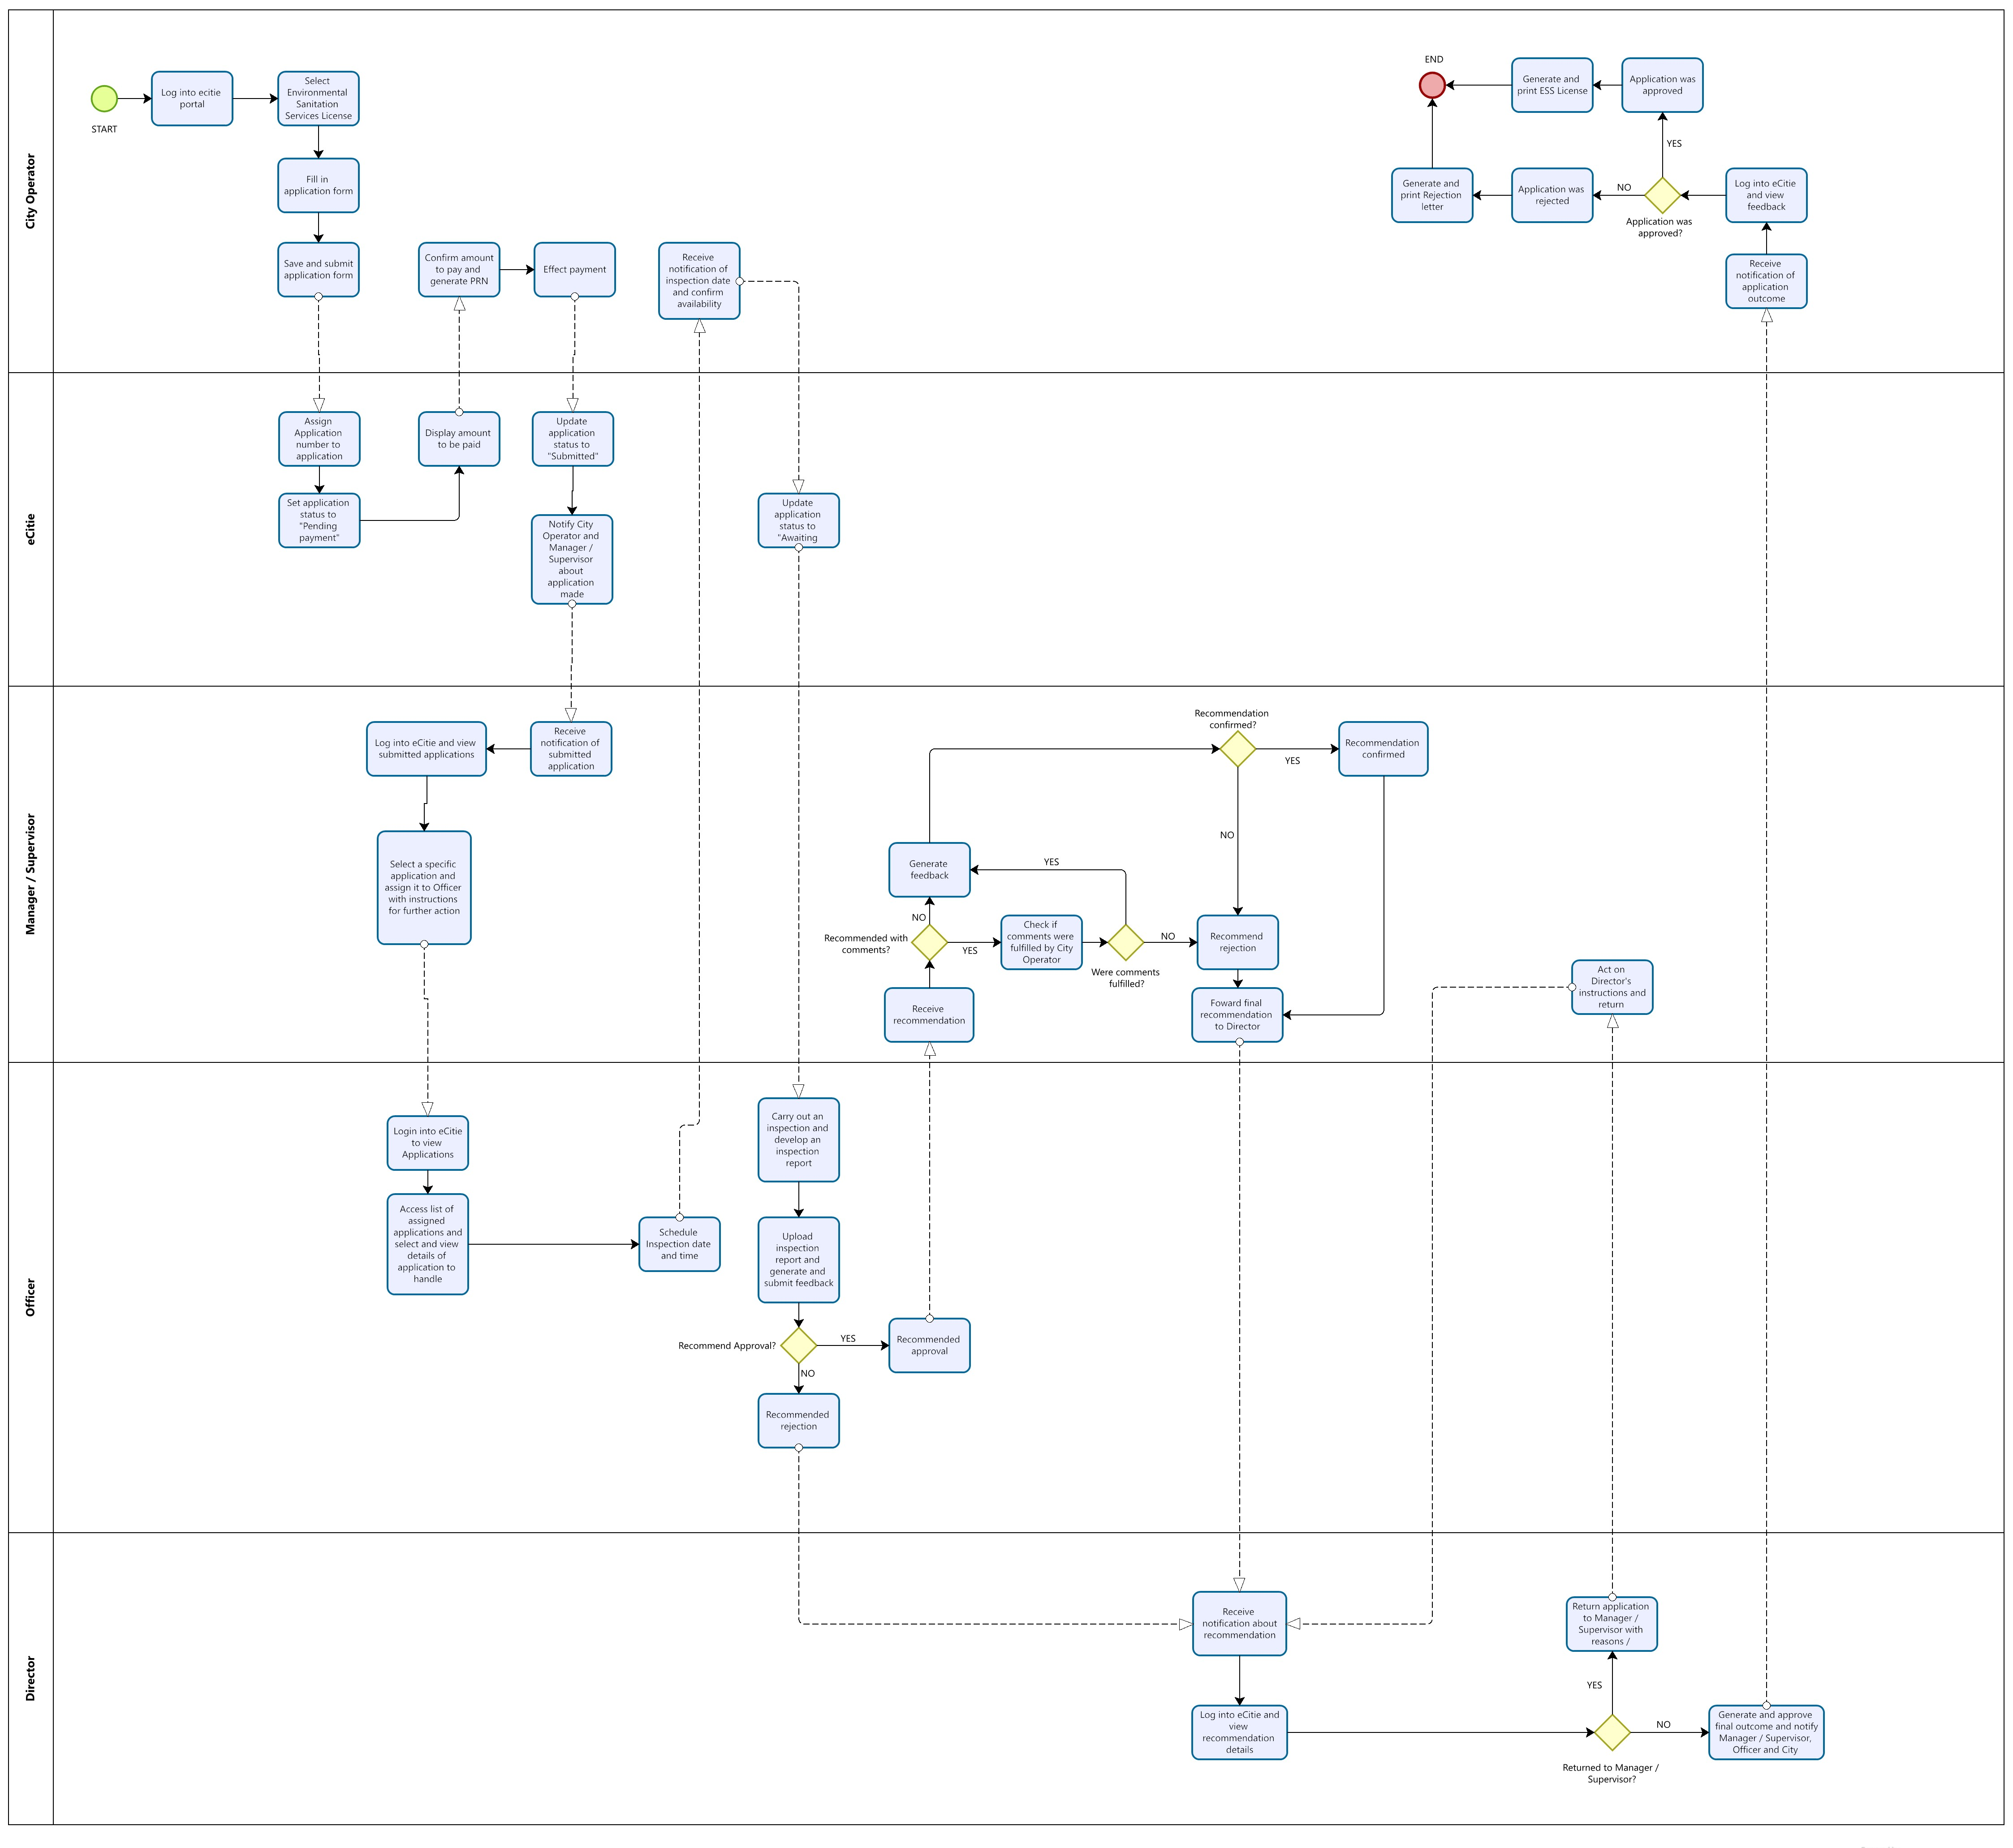

### Renewal of ESS License Process.

|  |  |
| --- | --- |
| **Name of Process:** | **Renewal of ESS License Process** |
| **Process Purpose:** | The purpose of this process is to enable a City Operator to apply for the renewal of his / her ESS license after it has expired. |
| **Process Scope:** | This process covers the steps which a City Operator takes to apply for the renewal of his / her ESS license after it has expired. It also covers the steps which an Officer takes to receive and view the City Operator’s application for renewal as well as the activities which he / she carries out before deciding to recommend either the approval or rejection of the application.  The process also involves the steps which the Director takes so as to either approve or reject the City Operator’s application for renewal. |
| **Actors** | * Director. * Manager / Supervisor. * Officer. * City Operator. |
| **Process Input:** | ESS License Renewal form along with any necessary attachments. |
| **Process Flow** | When the ESS license of a specific City Operator expires, the system automatically changes its status from **Active** to **Expired** before moving it from the list of active / running ESS licenses to that of the expired ones.  **When the City Operator is submitting his / her request for renewal of an expired ESS license.**   1. The City Operator logs onto the eCitie portal using his / her COIN and PIN. 2. Upon logging in, he / she selects **Environmental Sanitation Service License**. 3. The City Operator selects **Renew ESS License**. 4. Upon selecting Renew ESS License, the system displays a **Renewal of ESS License form** with the basic company details Automatically populated, i.e., equipment and company details, which the City Operator can edit by removing or adding a vehicle / equipment and attach any other required documents in the prescribed format before saving and submitting. 5. Upon submission, the City Operators file is updated and the system displays the amount of money to pay for the renewal and Inspection. 6. The City Operator confirms the amount to be paid before he / she selects a Collecting Agent and generates a Payment Reference Number (PRN). 7. Upon the City Operator generating a PRN, eCitie then saves the request and marks it as **Pending Payment**. 8. After the City Operator has effected the payment, eCitie automatically updates the status of the application to **Submitted**. 9. An email and SMS notification is then sent to the City Operator notifying him / her that KCCA has received his / her application. This notification also contains other details such as the **Application Number** that can be used to uniquely identify the City Operator’s application. 10. A system notification is also sent to the Manager / Supervisor, notifying him / her of the application that has been submitted.   **Note:** The Manager / Supervisor is not notified about the application until the City Operator has made the full payment.   1. The Manager / Supervisor logs into eCitie using his / her credentials to view all the pending applications. 2. The Manager / Supervisor then selects and views a specific application before assigning it to a specific Officer with instructions for further action.   **When the Officer is scheduling a date for inspection.**   1. Upon assignment to a specific Officer by the Manager / Supervisor, a system notification is sent to the selected Officer notifying him / her of the application which he / she has been assigned. 2. The Officer then logs into eCitie and views the list of all the submitted applications which have been assigned to him / her. 3. The Officer then continues to select and open one of the applications from the list in order to view its details**.** 4. When viewing the details of the selected application, the Officer clicks the **Schedule Inspection** button, and the system displays a form using which he / she selects a convenient **date and time** for the Inspection before submitting. 5. Upon submission, the system generates and sends an email and SMS notification to the City Operator notifying him / her about the date and time scheduled for Inspection. This notification contains the schedule details as well as a link which the City Operator has to open. 6. On opening the link, the City Operator is redirected to the system where he / she logs in and confirms availability for the proposed inspection date and time. 7. Upon the City Operator confirming his / her availability, a system notification is sent to the Officer notifying him / her about the confirmation that has been made by the City Operator.   (**Note:** If the City Operator does not confirm his / her availability on the proposed inspection date within three days, it will be taken that he / she has confirmed availability.)   1. The Officer then carries out the Inspection and develops an **Inspection** **Report** within a time period of 30 days**.** 2. After completing the inspection and developing an inspection report, the Officer logs into the system and continues to select and open a specific application before selecting **Generate Feedback** so as to open the **ESS Application Feedback Form**. 3. The Officer then uses the ESS Application Feedback Formto upload the inspection report and, according to the report, decides to either recommend **Approval**, **Approval with Comments** or **Rejection** of the application. 4. If the Officer recommends **Rejection** of the application after developing and uploading the inspection report, he / she selects **Recommend Rejection** on the ESS Application Feedback Form after filling it together with reasons for rejection before saving and submitting. 5. If the Officer recommends rejection, a system notification is sent to the Manager / Supervisor informing him / her about the recommendation which has been made by the Officer. A system notification is also sent to the Director.   (**Note:** When the Officer recommends rejection, the Manager / Supervisor only receives a notification but cannot act.)   1. The Director logs into the system to view all the Rejected applications, and he / she selects a specific rejection to review the inspection report before approving the rejection. 2. Upon the Director approving the Rejection, a system notification is sent to the Manager / Supervisor and Officer about the Director's approval of the Rejection. 3. A **Rejection Letter** is then generated by the system and an email / SMS notification is sent to the City Operator notifying him / her about the outcome of the application. This notification also contains a link which the City Operator can follow to log into his / her eCitie account and download the pdf format of the Rejection letter before printing it at his / her own convenience. 4. If the Director rejects the recommended rejection, he / she has to attach reasons for doing so. In this case, the Director’s response and reasons are then sent back to the Manager / Supervisor with instructions. 5. If the Officer recommends approval, a system notification is sent to the Manager / Supervisor who confirms the approval before forwarding it to the Director.   (**Note 1:** The Manager / Supervisor can turn the recommended approval into a rejection. In the case of such a rejection, a system notification is sent to the Director who handles it as documented in **step 13** above.  **Note 2:** In addition to confirming a recommended approval and turning an approval into a rejection, the Manager / Supervisor can also send it back to the concerned Officer with instructions.)   1. Upon submission, a system notification is sent to the Director notifying him / her about the recommended approval. 2. Upon the Director approving the recommendation, the system generates an ESS license and an email and SMS notification is sent to the City Operator notifying him / her about the approval. This notification contains the license details as well as a link which the City Operator has to open in order to access, generate and download the license in pdf format before printing it at his / her own convenience.   (**Note:** After logging in onto the system, the City Operator can only generate and download an ESS license which is active. This means that the City Operator cannot generate and print a license when it is either expired, suspended or revoked.)   1. When recommending **Approval with Comments**, the Officer fills the **Feedback Form** together with the reasons for doing so before submitting it. 2. On submission, a system notification is sent to the Manager / Supervisor. This notification also contains any additional requirements / conditions which the City Operator has to fulfil in order for the application to be approved together with the time period within which these requirements have to be fulfilled. 3. The Officer then follows up with the City Operator so as to know whether he / she has fulfilled the pending requirements. 4. If the City Operator has not yet fulfilled the pending requirements, the Manager / Supervisor recommends rejection of the application, otherwise, he / she recommends approval. If the Manager / Supervisor recommends rejection, the Director and Officer will be notified and the rejection will be forwarded to the Director and completed as documented in the steps **13**, **14**, **15** and **16** above. If the Manager / Supervisor recommends approval, the recommendation will be forwarded to the Director who will handle it as documented in the steps **18** and **19** above. |
| **Output** | Either renewed ESS License or Rejection Letter. |
| **Control Points and Measurements:** |  |

**Process Flow Chart for Renewal of ESS License Process.**

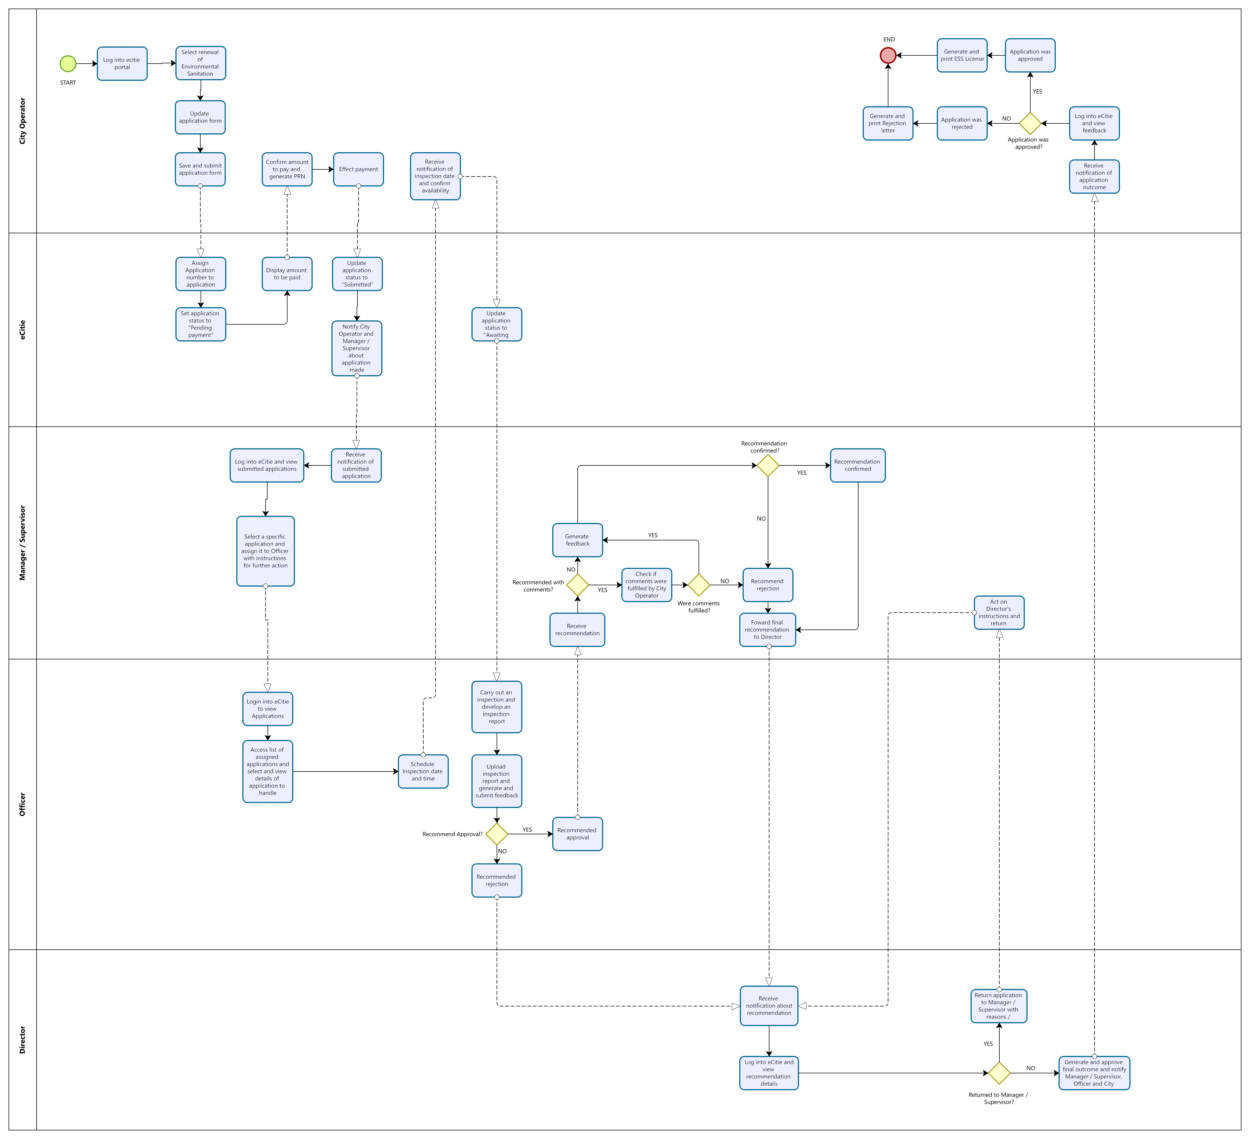

### Suspension and Revocation of ESS License Process.

|  |  |  |
| --- | --- | --- |
| **Name of Process:** | | **Suspension and Revocation of ESS License Process.** |
| **Process Purpose:** | The purpose of this process is to suspend a running ESS license of a specific City Operator who has defaulted or failed to comply with the terms and conditions which are attached to the said license. | |
| **Process Scope:** | This process covers the steps which an Officer takes to suspend an active ESS license of a specific City Operator who has defaulted or failed to comply with the terms and conditions attached to the said license.  It also covers the steps which the Director takes to either approve or reject the suspension of a specific City Operator’s ESS license. | |
| **Process Actors:** | * Director. * Manager / Supervisor. * Officer. * City Operator. | |
| **Process Input:** | The ESS License Number / COIN. | |
| **Process Flow:** | The process of cautioning, suspending or revoking a City Operator’s ESS license can be initiated by the Director, Manager / Supervisor or Officer.   1. When a complaint about a given City Operator is received, it is assigned to the Officer who carries out an investigation concerning the matter. The Officer then develops a **Complaint Report** which contains details of the reasons and details for suspension or revocation of the City Operator’s ESS license. 2. The Officer then logs into eCitie, opens the list of active / running ESS licenses and selects a specific City Operator’s ESS license to view its details. 3. In the selected ESS license, the Officer selects “**Penalize City Operator**”. 4. Upon selecting penalize, the system displays a form which he / she fills with reasons for penalizing the City Operator and attaches / uploads the developed Complaint Report before saving and submitting it to the Manager / Supervisor. In this form, the Officer can recommend that the City Operator should be **Cautioned** or have his / her license either **Suspended** or **Revoked**. 5. A system notification with details of the Officer`s recommendation is then sent to the Manager / Supervisor. 6. The Manager / Supervisor logs into the system to view the details of the Officer`s recommendation. Here the Manager / Supervisor can also view the Complaint Report. 7. The Manager / Supervisor then goes ahead to either **Confirm** the Officer`s recommendation, **Reject** or **Adjust** with reasons. 8. If the Manager / Supervisor decides to **Reject** the Officer`s recommendation with reasons / instructions, a notification is sent to the Officer with reasons for rejection together with any instructions. 9. If the Manager / Supervisor decides to **Adjust** the Officer`s recommendation, he / she can change it to a different penalty with reasons. In this situation, the Manager / Supervisor can decide to adjust the penalty and send it back to the Officer with instructions or adjust the penalty and then move it forward to the Director for final action. The Manager / Supervisor can also view and make any needed changes to the Complaint Report that was submitted by the Officer.   (**Note:** If the Manager / Supervisor adjusts the penalty and then sends it back to the Officer with reasons / instructions, the Officer makes the necessary updates as instructed before again sending it forward to the Manager / Supervisor for confirmation.)   1. A notification is sent to the Officer informing him / her about the adjustment that has been made together with the reasons. A system notification of the final recommendation is also sent to the Director for further action. 2. If the Manager / Supervisor decides to **Confirm** the Officer`s recommendation, a system notification is sent to the Director for further action. The Officer is also sent a system notification informing him / her about the confirmation by the Manager / Supervisor. 3. The Director logs into the system and selects a specific recommendation and views its details. Here the Director can also view the Complaint Report. 4. The Director then goes ahead to either **Approve** the Manager / Supervisor`s recommendation, **Reject**, **Adjust** with reasons or propose to **Revisit case**. 5. If the Director proposes to **Revisit case**, he / she provides any instructions which are then forwarded to the Manager / Supervisor. In this situation, the penalty is neither approved nor rejected by the Director but rather, it is sent back to the Manager / Supervisor to follow the additional instructions being given by the Director in relation to the City Operator’s case. After fulfilling the Director’s instructions, the Manager / Supervisor forwards the case back to the Director with the relevant recommendation. 6. If the Director decides to **Reject** the Manager / Supervisor`s recommendation with reasons, a notification is sent to the Manager / Supervisor and Officer with reasons for rejection together with any instructions. In this case, the status of that specific ESS license remains as **Active.** 7. If the Director decides to **Adjust** the Manager / Supervisor`s recommendation, he / she can change it to a different penalty with reasons. In this situation, the Director can decide to adjust the penalty and send it back to the Manager / Supervisor with instructions or adjust the penalty and then approve it. The Director can also view and make any needed changes to the Complaint Report that was submitted by the Officer.   (**Note:** If the Director adjusts the penalty and then sends it back to the Manager / Supervisor with reasons / instructions, the Manager / Supervisor makes the necessary changes as instructed before again sending it forward to the Director for approval.)   1. A notification is sent to the Manager / Supervisor and Officer informing them about the adjustment that has been made together with the reasons. 2. Depending on the adjustment that has been made by the Director, the status of the specific ESS permit is changed to either, **Cautioned**, **Suspend** and **Revoked**. The City Operator then receives an email / SMS notification about the action / penalty that has been made on his / her ESS license. 3. If the Director decides to **Approve** the Manager / Supervisor`s recommendation, the status of the specific ESS license is changed to either **Cautioned**, **Suspended** or **Revoked**. A system notification is also sent to the Manager / Supervisor and Officer about the Director`s decision. The City Operator then receives an email / SMS notification about the action / penalty that has been made on his / her ESS license.   **Note:**  **Caution:** When a City Operator is cautioned, the system status of his / her ESS license changes from **Active** to **Cautioned**. This ESS license is then moved from the list of active licenses to that of cautioned licenses. (A City Operator with a cautioned license is still allowed to operate). When cautioned, a City Operator receives both an email and SMS notification. The City Operator also receives a **Cautioning letter** (**Improvement notice**) which is generated by the system.  **Suspend:** When a City Operator is suspended, the system status of his / her ESS license changes from **Active** to **Suspended**. This ESS license is then moved from the list of active licenses to that of suspended licenses. (A City Operator with a suspended license is not allowed to operate until a given condition is fulfilled). When suspended, a City Operator receives both an email and SMS notification. The City Operator also receives a **Suspension letter** (**Stop notice**) which is generated by the system.  **Revoke:** When a City Operator is revoked, the system status of his / her ESS license changes from **Active** to **Revoked**. This ESS license is then moved from the list of active licenses to that of revoked licenses. (A City Operator with a revoked license is not allowed to operate. The revocation of a City Operator`s license runs until the expiry of the revoked license. During this period, the City Operator cannot apply for another license). When revoked, a City Operator receives both an email and SMS notification. The City Operator also receives a **Revocation letter** (**Revocation notice**) which is generated by the system. | |
| **Process Outputs:** | * System / email / SMS notifications. * ESS License Cautioned / Suspended / Revoked. * License Caution / Suspension / Revocation letter. | |
| **Exceptions to Normal Process Flow:** | None. | |
| **Control Points and Measurements:** | * When the Officer makes a recommendation, the Manager / Supervisor has to confirm it before it is approved by the Director. * The Manager / Supervisor can reject an Officer`s recommendation if it is lacking. In this case, a notification is sent to the Officer with reasons for rejection together with any instructions. * The Director can only receive a recommendation for action if it has been confirmed by the Manager / Supervisor. * The Director, Manager / Supervisor and Officer can track the progress of a given complaint. | |
| **Attachments** | None. | |

**Process Flow Chart for Suspension of ESS License Process.**

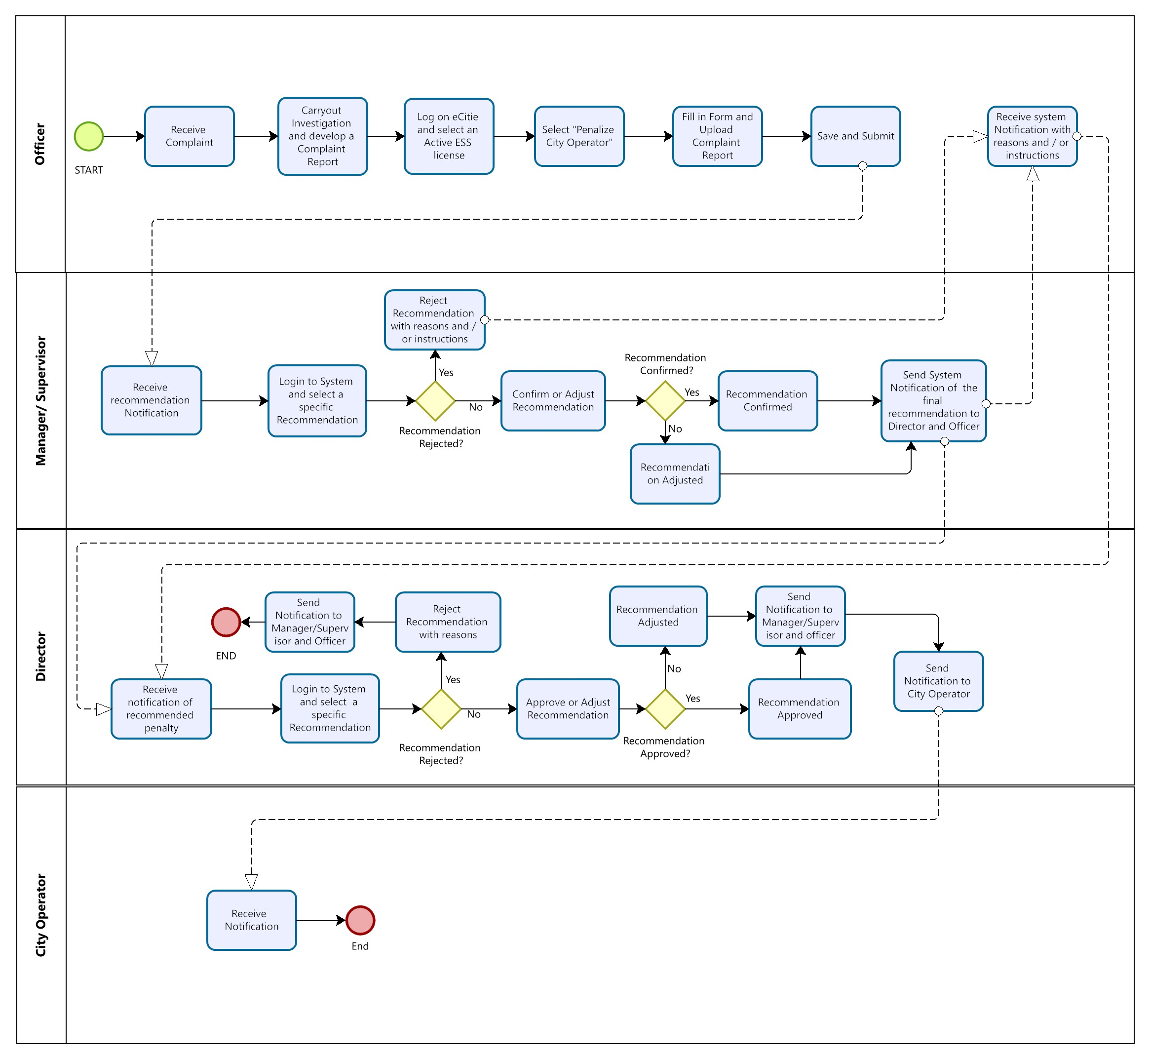

### Review of Appeal Process.

The purpose of this process is to revise a decision that was made to reject a given City Operator’s application for an ESS license. This is done after the City Operator (whose ESS license application was rejected) has made an appeal to the Minister of Kampala Capital City.

**Process flow.**

1. When the City Operator is dissatisfied with the Directors decision to reject his / her application for an ESS license, he / she appeals to the Minister of Kampala for review of the decision.
2. The minister writes a letter and sends it to the Director instructing him / her to review the City Operator’s Application.
3. The Director then forwards the necessary instructions to the concerned Officer for Action.

### Application for ESS License Form

Defintion of Field status

M – Mandatory

O – Optional

C – Conditional

Mp – Multiple

*AP-Auto populate*

Table 1; Application for ESS license form

| **Sr. No.** | **Field Name** | **Field Status** | **Reference For conditional field** | **Remarks** |
| --- | --- | --- | --- | --- |
| **Section A: City Operators’ Details.** | | | | |
|  | Name | AP |  | This field is auto populated basing on the Registration details in the City Operators eCitie Account |
| **Section B: Particulars of Applicant(s)** | | | | |
|  | Do you have a Kampala Trading License? | M |  | Select one option; **Yes** or **No**. |
|  | Company Name | C | Do you have a Kampala Trading License? | If City Operator selects **Yes** in field “2” above, this field should be Auto-Populated basing on the COIN.  If City Operator selects **No** in field “2” above, this field should be a Mandatory open text field. |
|  | Date of Incorporation or Registration | C | Do you have a Kampala Trading License? | If City Operator selects **Yes** in field “2” above, this field should be Auto-Populated basing on the COIN.  If City Operator selects **No** in field “2” above, this field should be a Mandatory open text field. |
|  | Name of Authorised Representatives. | M |  | Open Text Field |
|  | Address | M |  | Open Text Field |
|  | Principle place of Business of Applicant | C | Do you have a Kampala Trading License? | If City Operator selects **Yes** in field “2” above, this field should be Auto-Populated basing on the COIN.  If City Operator selects **No** in field “2” above, this field should be a Mandatory open text field. |
| **Section C: Nature of Environment Sanitation Service(s) to Provide** | | | | |
|  | Type of Service(s) | M |  | Check list with a list of services to be selected by applicant.  (Can select more than one)   * Emptying & Transportation of FSM and Waste Water. * Mobile Toilets. |
|  | Area(s) of operation | M |  | Check list contains the 5 Division of Kampala City.  (Can select more than one) |
|  | Description of Suitability to provide Service(s). (Attach proof, if any, including certificates, list of assignments and contracts successfully completed). | M |  | Open text field |
| **Section D: Proof of ability to provide Service.** (Optional Section for when city operator is providing Faecal Sludge Transportation Service) | | | | |
|  | List and Details of Vehicles. (Including Model, make, capacity) | M |  | Open text field |
|  | Proof of fitness of Vehicle | M |  | Scan and upload IOV letter in PDF. |
|  | Proof of ownership | M |  | Scan and upload log book(s)/lease agreement in PDF |
|  | Third Party Insurance | M |  | Scan and upload third party insurance in PDF. |
|  | Proposed Disposal Site(s) | M |  | Scan and upload letter of approval for disposal at licensed disposal sites. |
|  | Any Other Relevant Documents | O |  | Scan and upload |

### Renewal of ESS License Form

The form for Renewal of ESS license is similar to the Application for ESS License process form as described Table 1 above.

### Suspension or Revocation of ESS License Form

Table 2; Suspension of ESS License Form

| **Sr. No.** | **Field Name** | **Field Status** | **Reference For conditional field** | **Remarks** |
| --- | --- | --- | --- | --- |
|  | Company Name | AP |  | Auto populated basing on name of company selected from list of Active ESS Licenses. |
|  | Reasons for Suspension | M |  | Open Text Field. |
|  | Recommendation | M |  | Select one option;  Suspension, Caution. |
|  | Suspension Report | M |  | Upload |

# APPENDICES.

This section contains the different appendices of ESS license processes. These appendices are automatically generated by the system. They include the following;

1. Rejection Notice.

This notice is generated by the system and sent to the City Operator when his / her request for an ESS license has been rejected because of a given reason.

1. Improvement (Caution) Notice.

This notice is generated and sent to a City Operator so as to extend a caution. It is sent to caution a City Operator who has violated the terms and conditions of operation of the ESS license.

1. Stop (Suspension) Notice.

This notice is generated and sent to a City Operator when his ESS license has been suspended. This notice is sent to notify a City Operator whose ESS license has been suspended so as to inform him about the reasons for suspension as well as the steps that need to be followed so as to have the license reinstated.

1. Revocation Notice.

This notice is generated and sent to a City Operator when his ESS license has been revoked. This notice is sent to notify a City Operator whose ESS license has been revoked so as to inform him about the reasons for revocation as well as the steps that need to be followed so as to get another license.

These notices are displayed below;

**DIRECTORATE OF PUBLIC HEALTH SERVICES**

**AND ENVIRONMENT**

**Serial Number:**

Date & Time of Issuance

**REJECTION NOTICE**

**TO:** ,

, ,

P.O.BOX ,

Kampala, Uganda.

This is to notify you that the application for an Environmental Sanitation Services (ESS) License (Application number: ) which you submitted on  has been rejected in accordance to **section 18** of the **KCCA (Sewerage and Faecal Sludge Management) ordinance, 2019** for the following reasons;

1. **………………………………………………………………………………………………………………………………………………………………………………………………………………………………………………………**
2. **………………………………………………………………………………………………………………………………………………………………**

**Y**ou are hereby advised to solve the above-mentioned issues and re-apply for a license in order to be allowed to operate.

**Note:** If you are not satisfied with the rejection, you are encouraged to appeal to the Minister of Kampala Capital City for review of the decision.

**YOU ARE FURTER NOTIFIED** that operating without a valid license will attract severe penalties. **STAND DULY WARNED.**

**<Director`s signature>**

**<Director`s Name>**

**DIRECTOR PUBLIC HEALTH SERVICES AND ENVIRONMENT**

**DIRECTORATE OF PUBLIC HEALTH SERVICES**

**AND ENVIRONMENT**

Serial Number:

Date & Time of Issuance

**IMPROVEMENT NOTICE**

**TO:** ,

, ,

P.O.BOX ,

Kampala, Uganda.

**TAKE NOTICE that on the ………. day …...of ….….20….at……… Hours your Company defaulted against the Environmental Sanitation Services Operational terms and conditions as stated below;**

1. **………………………………………………………………………………………………………………………………………………………………………………………………………………………………………………………**
2. **………………………………………………………………………………………………………………………………………………………………**

**YOU ARE HEREBY ORDERED to make the following improvements within a period of………………...days from the receipt of this Notice;**

1. **………………………………………………………………………………………………………………………………………………………………………………………………………………………………………………………**
2. **………………………………………………………………………………………………………………………………………………………………**

**YOU ARE FURTHER NOTIFIED that failure to comply with this notice shall result in Revocation of your Operation License/or criminal proceeding. STAND DULY WARNED.**

**<Director`s signature>**

**<Director`s Name>**

**DIRECTOR PUBLIC HEALTH SERVICES AND ENVIRONMENT**

**DIRECTORATE OF PUBLIC HEALTH SERVICES**

**AND ENVIRONMENT**

**Serial Number:**

Date & Time of Issuance

**STOP NOTICE**

**TO:** ,

, ,

P.O.BOX ,

Kampala, Uganda.

This is to hereby notify you that your **Environmental Sanitation Services license**, (License no.: ) which has been running since  has been **SUSPENDED** in accordance to **section 22** of the **KCCA (Sewerage and Faecal Sludge Management) ordinance, 2019** for the following reasons;



**YOU ARE HEREBY ORDERED TO STOP** all activities of collecting and transporting faecal sludge with effect from today, . Your license will be reinstated only after the conditions below have been fulfilled;



**YOU ARE FURTER NOTIFIED** that failure to comply with this notice will result in the permanent **REVOCATION** of this license. **STAND DULY WARNED.**

**<Director`s signature>**

**<Director`s Name>**

**DIRECTOR PUBLIC HEALTH SERVICES AND ENVIRONMENT**

**DIRECTORATE OF PUBLIC HEALTH SERVICES**

**AND ENVIRONMENT**

**Serial Number:**

Date & Time of Issuance

**REVOCATION NOTICE**

**TO:** ,

, ,

P.O.BOX ,

Kampala, Uganda.

This is to hereby notify you that your **Environmental Sanitation Services license**, (License no.: ) which has been running since  has been **REVOKED** in accordance to **section 22** of the **KCCA (Sewerage and Faecal Sludge Management) ordinance, 2019** for the following reasons;



**YOU ARE HEREBY ORDERED TO STOP** all activities of collecting and transporting faecal sludge with immediate effect. This license cannot be reinstated and you will have to apply for another license after the conditions below have been fulfilled;



**FAILURE TO COMPLY WILL ATTRACT SEVERE PENALTIES.**

**<Director`s signature>**

**<Director`s Name>**

**DIRECTOR PUBLIC HEALTH SERVICES AND ENVIRONMENT**